**Course Code: EE461**

**Assignment**

**PREPARED BY**

**Khandoker Samiul Hoque**

**Student Id: 19837**

**1 No Answer:**

Design:  
module bit_detect_rtl (

input [7:0] data_input,

output zeroflag_rtl,

output oneflag_rtl

);

assign zeroflag_rtl = ~|data_input;

assign oneflag_rtl = |data_input;

endmodule  
  
test bench :

module tb;

reg [7:0] data_input;

wire zeroflag_rtl, oneflag_rtl, zeroflag_gate, oneflag_gate;

bit_detect_rtl foo_rtl (.data_input(data_input),.zeroflag_rtl(zeroflag_rtl),.oneflag_rtl(oneflag_rtl));

reg clk = 0;

always

#5

clk = ~clk;

initial begin

data_input = 8'b00100100;

#5;

data_input = 8'b10000001;

#5;

data_input = 8'b00001001;

#5;

$finish;

end

always @(posedge clk) begin

$display("data_input = %b, zeroflag_rtl = %b, oneflag_rtl = %b, zeroflag_gate = %b, oneflag_gate = %b",data_input, zeroflag_rtl, oneflag_rtl, zeroflag_gate, oneflag_gate);

end

endmodule

output:



design:

module detect_gate (input [7:0] data_in,output zeroflag_gate,output oneflag_gate);

wire [7:0] not_data_in;

wire [7:0] or_data_in;

assign not_data_in = ~data_in;

assign or_data_in = |data_in;

and gate1 (zeroflag_gate, not_data_in);

and gate2 (oneflag_gate, or_data_in);

endmodule

testbench:

module tb;

reg [7:0] data_in;

wire zeroflag_rtl, oneflag_rtl, zeroflag_gate, oneflag_gate;

detect_gate foo_gate (

.data_in(data_in),

.zeroflag_gate(zeroflag_gate),

.oneflag_gate(oneflag_gate)

);

reg clk = 0;

always

#10

clk = ~clk;

initial begin

data_in = 8'b00100100;

#20;

data_in = 8'b10000001;

#20;

data_in = 8'b00001001;

#20;

$finish;

end

always @(posedge clk) begin

$display("data_in = %b, zeroflag_rtl = %b, oneflag_rtl = %b, zeroflag_gate = %b, oneflag_gate = %b", data_in, zeroflag_rtl, oneflag_rtl, zeroflag_gate, oneflag_gate);

end

endmodule

output:

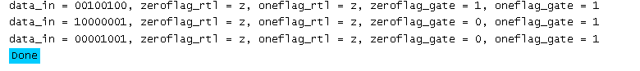

When tested with the same input patterns, the bit detector module's RTL and gate level implementations provide different outputs for the zeroflag and oneflag signals.The RTL implementation's zeroflag rtl and oneflag rtl signals have a value of 0 for every one of the three input patterns (00100100, 10000001, and 00001001).For each of the three input patterns in the gate level integration, the zeroflag gate and oneflag gate signals are set to 1.

**2 No Answer:**

**Design:**module number_converter (input [3:0] x_input,output [3:0] x_output);

wire sign_bit = x_input[3];

wire [2:0]

magnitude_bits = sign_bit ? ~x_input[2:0] + 1 : x_input[2:0];

assign x_output = {sign_bit, magnitude_bits};

endmodule  
  
**TestBench:**module tb;

reg [3:0] x_input;

wire [3:0] x_output;

number_converter prob2(.x_input(x_input),.x_output(x_output));

initial begin

$monitor("x_input = %b, x_output = %b", x_input, x_output);

x_input = 4'b0101;

#5 // Test unsigned positive input

x_input = 4'b1011;

#5 // Test unsigned negative input

x_input = 4'b0101;

#5

x_input = 4'b1101;

#5

$finish;

end

endmodule

**Output:**

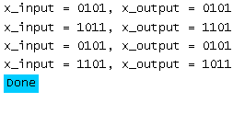

**3 No Answer:**

**Design:**

module mux4_1_cont_assign (input [3:0] data_input,input [1:0] sel, output wire out);

assign out = (sel == 2'b00) ? data_input[0] :

(sel == 2'b01) ? data_input[1]:

(sel == 2'b10) ? data_input[2] :

data_input[3];

endmodule

**TestBench:**module tb;

reg [3:0] data_input;

reg [1:0] sel;

wire out;

mux4_1_cont_assign prob3(.data_input(data_input), .sel(sel), .out(out));

initial begin

$dumpfile("tb.vcd");

$dumpvars(0,tb);

// Test case 1

data_input = 4'b0001;

sel = 2'b00;

$display("Test case 1: data_input=%b, sel=%b, out=%b", data_input, sel, out);

#10

// Test case 2

data_input = 4'b0010;

sel = 2'b01;

$display("Test case 2: data_input=%b, sel=%b, out=%b", data_input, sel, out);

#10

// Test case 3

data_input = 4'b0100;

sel = 2'b10;

$display("Test case 3: data_input=%b, sel=%b, out=%b", data_input, sel, out);

#10

// Test case 4

data_input = 4'b1000;

sel = 2'b11;

$display("Test case 4: data_input=%b, sel=%b, out=%b", data_input, sel, out);

#10

//Test case5

sel = 2'b01;

data_input = 4'bz;

$display("Test case 5: data_input=%b, sel=%b, out=%b", data_input, sel, out);

#10

//Test case 6

sel = 2'b01;

data_input = 4'bx;

$display("Test case 6: data_input=%b, sel=%b, out=%b", data_input, sel, out);

#10

$finish();

end

endmodule

**Output:**

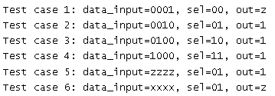

**Graph Output:**

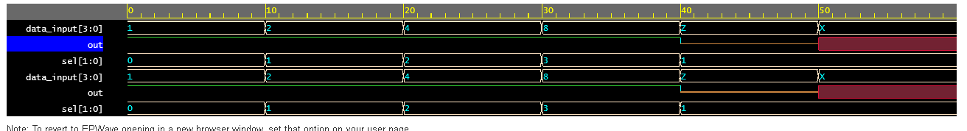

**4 No Answer:**

a.

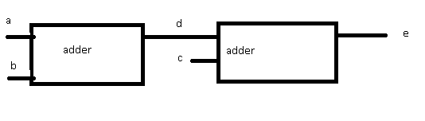

b.

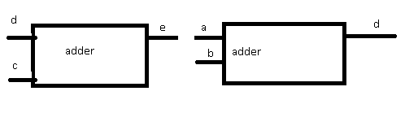

Even if the identical inputs 'a', 'b', and 'c' are used, the two code snippets will output different values for 'd' and 'e' because of the variations in the sequence of assignments and the adders order.

**5 No Answer:**

module mux(a, b, c, d, e, sel, out);

input a, b, c, d, e;

input [2:0] sel;

output reg out;

always @(*) begin

case(sel)

3'b000: out = a;

3'b001: out = b;

3'b010: out = c;

3'b011: out = d;

3'b100: out = e;

default: out = a; // assign a default value to avoid inferred latches

endcase

end

endmodule

After assigning a value to the out by default, which will make this to avoid, inferred latches.

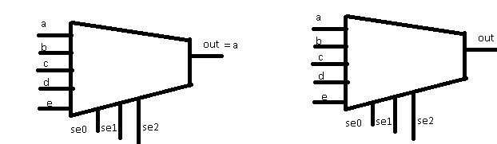

New old